Assignment 8
Task 1
General Description:
Sarah, a 32-year-old marketing manager, uses an urban mobility app to navigate her busy morning schedule. She needs to drop off her kids at school, attend a meeting at the office, and pick up a prescription from the pharmacy before heading to work.
Scenario Variables:
- Location and Setting:
  - Locations: Home, school, subway station, office, pharmacy.
  - Setting: Urban city with moderate traffic, well-connected public transportation.
- Movement and Posture:
  - Movement: Walking to the school and subway station, riding the subway, walking to the pharmacy and office.
  - Posture: Walking while using the app, sitting on the subway.
- Workload, Distractions, and Activities:
  - Workload: High, balancing multiple tasks (school drop-off, commuting, pharmacy visit).
  - Distractions: Managing kids, navigating busy streets, checking the time.
  - Activities: Checking the app for optimal routes, receiving notifications about public transport schedules, checking pharmacy hours.
- Devices and Usages:
  - Device: Smartphone.
  - Usage: The app provides walking directions to the school, suggests the best subway route to the office, and notifies Sarah when to get off the subway. It also reminds her about the pharmacy stop and shows the shortest walking route from the subway station to the pharmacy.
- Users and Personas:
  - User: Sarah, a 32-year-old marketing manager and mother of two.
  - Persona: Busy professional and parent, tech-savvy, relies on efficient time management tools.
Scenario Transition
After completing her morning tasks, Sarah now needs to attend a business lunch and run a quick errand at a nearby electronics store.
Scenario 2: Midday Business Lunch and Errand
General Description:
Post-meeting, Sarah has a scheduled business lunch at a downtown restaurant and needs to buy a charger from an electronics store nearby before returning to her office for the afternoon.
Scenario Variables:
- Location and Setting:
  - Locations: Office, restaurant, electronics store, office.
  - Setting: Bustling downtown area, pedestrian-friendly, with bike and scooter rentals available.
- Movement and Posture:
  - Movement: Walking from the office to the restaurant, renting a scooter to the electronics store, walking back to the office.
  - Posture: Walking and riding a scooter while using the app.
- Workload, Distractions, and Activities:
  - Workload: Moderate, focused on professional engagement and a quick errand.
  - Distractions: Checking emails, navigating downtown streets, managing time efficiently.
  - Activities: Using the app to find the restaurant, checking menu options beforehand, locating the nearest scooter rental, and navigating to the electronics store.
- Devices and Usages:
  - Device: Smartphone.
  - Usage: The app provides walking directions to the restaurant, sends notifications about the best time to leave based on current traffic, shows available scooter rentals, and provides a route to the electronics store. It also sends reminders about her upcoming afternoon meetings.
- Users and Personas:
  - User: Sarah, a 32-year-old marketing manager.
  - Persona: Busy professional needing to optimize travel time between work and personal tasks, appreciates seamless integration with calendar and efficient urban mobility solutions.
In these scenarios, the urban mobility app plays a crucial role in simplifying Sarah's movements around the city, helping her stay on schedule, and ensuring she can efficiently manage both personal and professional tasks. The app's integration with her calendar and real-time updates on transportation options make it an indispensable tool for her daily urban navigation.
Task 2
a) Suitable UEQ-Short Items and Questions
- Efficiency:
  - UEQ-Short Item: Efficient/inefficient
  - Survey Question: "Was the lecture content delivered efficiently?"
- Clarity:
  - UEQ-Short Item: Clear/confusing
  - Survey Question: "Was the lecture material clear and understandable?"
- Stimulation:
  - UEQ-Short Item: Exciting/boring
  - Survey Question: "Did you find the lecture content stimulating?"
- Dependability:
  - UEQ-Short Item: Predictable/unpredictable
  - Survey Question: "Was the lecture structure predictable?"
b) Additional Lecture-Specific Question
- Question: "How relevant was the lecture content to your current studies?"
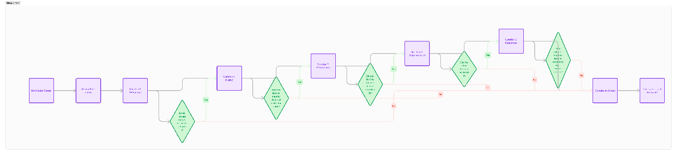
c) Frequency and Timing of Experience Samples
The experience samples should be collected twice per lecture: once around the middle of the lecture and once at the end. This allows for capturing the student's experience during the lecture and their overall impression at the end. The timing minimizes disruption by avoiding too many interruptions while still gathering meaningful data.
d) Data Transmission and Anonymity
- Data to be transmitted:
  - Survey responses
  - Timestamp of the response
  - Course/lecture identifier
- Anonymity or Pseudonymity:
  - Pseudonymous
- Advantages and Disadvantages:
Advantages:
  - For Data Analysis:
    - Allows tracking of responses over time for the same user, facilitating longitudinal studies.
    - Enables personalized feedback and improvements based on user patterns.
  - For the User:
    - Provides some level of privacy while allowing for personalized insights.
Disadvantages:
  - For Data Analysis:
    - Pseudonymity might still carry some privacy risks if identification numbers are somehow linked back to individuals.
  - For the User:
    - Users might still feel concerned about their privacy, knowing their responses can be tracked over time.
e) Paper Prototype
1. Notification Screen
- Caption: Notification appears in the Android Notification Bar.
2. Survey Start Screen
- Caption: User opens the app and sees a welcome message with a "Start Survey" button.
3. Question 1 (Efficiency)
- Caption: "Was the lecture content delivered efficiently?" with a Likert scale (1-5).
4. Question 2 (Clarity)
- Caption: "Was the lecture material clear and understandable?" with a Likert scale (1-5).
5. Question 3 (Stimulation)
- Caption: "Did you find the lecture content stimulating?" with a Likert scale (1-5).
6. Question 4 (Dependability)
- Caption: "Was the lecture structure predictable?" with a Likert scale (1-5).
7. Question 5 (Relevance)
- Caption: "How relevant was the lecture content to your current studies?" with a Likert scale (1-5).
8. Completion Screen
- Caption: "Thank you for your feedback!" with an option to close the survey.

